UNITED STATES
SECURITIES AND EXCHANGE COMMISSION
Washington, D.C. 20549
FORM 8-K
CURRENT REPORT
Pursuant to Section 13 or 15(d) of the Securities Exchange Act of 1934
Date of Report (Date of earliest event reported): May 7, 2026

SERVE ROBOTICS INC.
(Exact Name of Registrant as Specified in Charter)
Delaware |  |  |  |  |  | 001-42023 |  |  |  |  |  | 85-3844872
(State or Other Jurisdiction  of Incorporation) |  |  |  |  |  | (Commission File Number) |  |  |  |  |  | (IRS Employer  Identification No.)
730 Broadway  Redwood City, CA |  |  |  |  |  | 94063
(Address of Principal Executive Offices) |  |  |  |  |  | (Zip Code)
(818) 860-1352
(Registrant’s telephone number, including area code)
N/A
(Former Name or Former Address, if Changed Since Last Report)
Check the appropriate box below if the Form 8-K filing is intended to simultaneously satisfy the filing obligation of the registrant under any of the following provisions:
☐ Written communications pursuant to Rule 425 under the Securities Act (17 CFR 230.425)
☐ Soliciting material pursuant to Rule 14a-12 under the Exchange Act (17 CFR 240.14a-12)
☐ Pre-commencement communications pursuant to Rule 14d-2(b) under the Exchange Act (17 CFR 240.14d-2(b))
☐ Pre-commencement communications pursuant to Rule 13e-4(c) under the Exchange Act (17 CFR 240.13e-4(c))
Securities registered pursuant to Section 12(b) of the Act:
Title of each class |  |  |  |  |  | Trading Symbol(s) |  |  |  |  |  | Name of each exchange on which registered
Common Stock, par value $0.0001 per share |  |  |  |  |  | SERV |  |  |  |  |  | The Nasdaq Capital Market
Indicate by check mark whether the registrant is an emerging growth company as defined in Rule 405 of the Securities Act of 1933 (§230.405 of this chapter) or Rule 12b-2 of the Securities Exchange Act of 1934 (§240.12b-2 of this chapter).
Emerging growth company ☒
If an emerging growth company, indicate by check mark if the registrant has elected not to use the extended transition period for complying with any new or revised financial accounting standards provided pursuant to Section 13(a) of the Exchange Act. ☐

Item 2.02. Results of Operations and Financial Condition.
On May 7, 2026, Serve Robotics Inc. (the “Company”) announced its financial results for the three months ended March 31, 2026. The full text of the press release issued in connection with the announcement is furnished as Exhibit 99.1 to this Current Report on Form 8-K.

Item 7.01. Regulation FD Disclosure.
On May 7, 2026, the Company made available on its website a revised Company investor presentation. A copy of the presentation is furnished as Exhibit 99.2 to this Current Report on Form 8-K.
The information in this Form 8-K (including Exhibits 99.1 and 99.2) shall not be deemed “filed” for purposes of Section 18 of the Securities Exchange Act of 1934, as amended (the “Exchange Act”), or otherwise subject to the liabilities of that section, nor shall it be deemed incorporated by reference in any filing under the Securities Act of 1933, as amended, or the Exchange Act, except as expressly set forth by specific reference in such a filing.

Item 9.01 Financial Statements and Exhibits.
(d)List of Exhibits.
Exhibit  Number |  |  |  |  |  | Description
99.1 |  |  |  |  |  | Press release, dated May 7, 2026
99.2 |  |  |  |  |  | Investor Presentation, dated May 2026
104 |  |  |  |  |  | Cover Page Interactive Data File (embedded within the Inline XBRL document)

1

SIGNATURES
Pursuant to the requirements of the Securities Exchange Act of 1934, the registrant has duly caused this report to be signed on its behalf by the undersigned hereunto duly authorized.
 |  |  | Serve Robotics Inc.
Dated: May 7, 2026 |  |  | /s/ Ali Kashani
 |  |  | Ali Kashani
 |  |  | Chief Executive Officer and Director
Dated: May 7, 2026 |  |  | /s/ Brian Read
 |  |  | Brian Read
 |  |  | Chief Financial Officer

2
Exhibit 99.1
Serve Robotics Announces First Quarter 2026 Results with 3X Sequential Revenue Growth

•Revenue scaled ahead of plan; Q1 revenue of $3.0 million, up 238% sequentially and 578% year over year, reflecting growth across all offerings.

•Entered into additional vertical through acquisition of Diligent Robotics; expanding operating footprint to 44 cities across 14 states.

•Improved gross margin over prior quarter, supported by growing software revenue and increasing revenue per robot and operating efficiency.

SAN FRANCISCO, May 7, 2026 -- Serve Robotics Inc. (the “Company” or “Serve”) (Nasdaq: SERV), a leading autonomy and robotics company, today announced financial results for the first quarter ended March 31, 2026.

“Q1 marks a fundamental shift for Serve. We are leading the development of Physical AI in the real world, operating across multiple physical domains while building towards a unified autonomy platform,” said Dr. Ali Kashani, Serve’s Co-founder and CEO. “Three months into 2026, we are executing against the plan we laid out, with strong early proof points across revenue growth, operational scale, and platform expansion. The investments we made over the past year are beginning to compound, reinforcing our position as a multi-domain autonomy platform and expanding the long-term opportunity ahead.”

"Serve is beginning to convert scale into a stronger financial model,” said Brian Read, CFO of Serve. “Revenue grew significantly, recurring and software revenue became a larger part of the mix, and gross margin percentage improved meaningfully. We remain focused on increasing revenue per robot and per operating hour, driving operating leverage, and building a more durable recurring revenue base, supported by a strong balance sheet.”

Business Highlights
•Multi-Domain Platform Established: Operated as a unified business across sidewalk delivery and healthcare robotics in Q1 following the Diligent Robotics acquisition.
•Operating Footprint Expanded: Now active across 44 cities in 14 states, driven by new market launches, hospital network additions, and continued expansion in existing markets.
•Fleet Scale Transitioning to Productivity: With approximately 2,000 robots deployed, focus has shifted from fleet expansion to increasing revenue per robot.
•Revenue Becoming More Recurring and Diversified: Software services contributed approximately one-third of Q1 revenue, with just under half of total revenue now recurring.
•Healthcare Platform Advancing: Diligent Robotics integration remains on plan, with a growing hospital pipeline and continued expansion of healthcare deployments.
•Approaching 2 Million Deliveries: Combined fleet nearing 2 million cumulative deliveries across indoor and outdoor environments, demonstrating scale and operational maturity.
Financial Highlights
•Revenue: Revenue of $3.0 million, increasing 238% sequentially and 578% year-over-year.
•Balance Sheet: Maintained a strong liquidity position of $197.4 million as of March 31, 2026.
•Outstanding Shares: Approximately 76 million shares of common stock outstanding as of March 31, 2026.

Outlook

The Company is reaffirming its 2026 financial guidance of approximately $26 million in full year revenue; and 2026 Non-GAAP operating expense of $160 to $170 million.

Supplemental Financial Information
The key metrics and financial tables outlined below are metrics that provide management with additional understanding of the drivers of business performance and the Company’s ability to deliver stockholder return. Investors should not place undue reliance on these metrics as indicators of future or expected results. The Company’s presentation of these metrics may differ from similarly titled metrics presented by other companies and therefore comparability may be limited.

Table 1
Key Metrics
(unaudited)
 |  |  | Three Months Ended
 |  |  | March 31, 2026(3) |  |  |  |  |  | December 31, 2025 |  |  |  |  |  | March 31, 2025
Daily Active Robots (1) |  |  | 812 |  |  |  |  |  | 547 |  |  |  |  |  | 73
Daily Supply Hours (2) |  |  | 10,295 |  |  |  |  |  | 6,676 |  |  |  |  |  | 648
(1)Daily Active Robots: The Company defines daily active robots as the average number of robots performing deliveries during the period.
(2)Daily Supply Hours: The Company defines daily supply hours as the average number of hours the Company’s robots are available to perform daily deliveries during the period.
(3)The key metrics reported for the three months ended March 31, 2026 are inclusive of the outdoor and indoor robot fleet.

Table 2
Disaggregation of Revenue
(in thousands)
(unaudited)

 |  |  | Three Months Ended
 |  |  | March 31, 2026 |  |  |  |  |  | December 31, 2025 |  |  |  |  |  | March 31, 2025
Fleet services |  |  | $ | 1,958 |  |  |  |  | $ | 648 |  |  |  |  | $ | 211
Software services |  |  | 1,026 |  |  |  |  |  | 234 |  |  |  |  |  | 229
Total revenue |  |  | $ | 2,984 |  |  |  |  | $ | 882 |  |  |  |  | $ | 440

Quarterly Conference Call Information
Management will host a conference call and webcast today at 2:00 p.m. PT / 5:00 p.m. ET to discuss the financial results and provide a corporate update. A live webcast and replay can be accessed from the investor relations page of Serve's website at investors.serverobotics.com.

Individuals interested in listening to the conference call may do so by dialing 800-715-9871 and referencing conference ID 2664698.
About Serve

Serve Robotics (Nasdaq: SERV) designs and operates autonomous robots that navigate and operate in complex, human-centric environments. Since spinning off from Uber in 2021, Serve has deployed more than 2,000 robots across the U.S., reaching a population of approximately 3 million and supporting delivery for more than 4,000+ restaurants. In 2026, Serve acquired Diligent Robotics, expanding its operations beyond sidewalk delivery into indoor service robots used in hospitals. Serve designs both the hardware and software behind its robots, enabling them to operate safely in public and private environments at scale.

For further information about Serve (Nasdaq: SERV), please visit www.serverobotics.com or follow us on social media via X (Twitter), Instagram, or LinkedIn @serverobotics.
Forward Looking Statements
This press release contains “forward-looking statements,” within the meaning of Section 27A of the Securities Act of 1933, as amended, Section 21E of the Securities Exchange Act of 1934, as amended, and the Private Securities Litigation Reform Act of 1995. Forward-looking statements may be identified by the context of the statement and generally arise when we or our management are discussing our beliefs, estimates or expectations. Such statements generally include the words “believes,” “plans,” “intends,” “targets,” “may,” “could,” “should,” “will,” “expects,” “estimates,” “suggests,” “anticipates,” “outlook,” “continues,” or similar expressions. These statements are not historical facts or guarantees of future performance, but represent management’s belief at the time the statements were made regarding future events which are subject to certain risks, uncertainties and other factors, many of which are outside of our control. Actual results and outcomes may differ materially from what is expressed or forecast in such forward-looking statements. Forward-looking statements include statements regarding the Company’s future revenue generation, business and investment strategy, timing of robot manufacturing and deployment, ability to expand to additional markets, capabilities of the Company’s robots, outcomes of planned and completed acquisitions, partnerships with multiple delivery platforms, and timing and ability to scale to commercial production.

The forward-looking statements contained in this press release are also subject to other risks and uncertainties, including those more fully described in our filings with the Securities and Exchange Commission (“SEC”), including in the sections entitled “Risk Factors” and “Management’s Discussion and Analysis of Financial Condition and Results of Operations'' in our Annual Report on Form 10-K for the year ended December 31, 2025, and in the Company’s subsequent SEC filings. The Company can give no assurance that the plans, intentions, expectations or strategies as reflected in or suggested by those forward-looking statements will be attained or achieved. The forward-looking statements in this presentation are based on information available to the Company as of the date hereof, and the Company disclaims any obligation to update any forward-looking statements, except as required by law. These forward-looking statements should not be relied upon as representing the Company’s views as of any date subsequent to the date of this presentation.

Non-GAAP Measures of Financial Performance

To supplement the Company’s financial statements, which are presented on the basis of U.S. generally accepted accounting principles (“GAAP”), the following non-GAAP measures of financial performance are included in this release: non-GAAP cost of sales, non-GAAP general and administrative expense, non-GAAP research and development expense, non-GAAP operations expense, non-GAAP sales and marketing expense, non-GAAP operating expense, adjusted EBITDA, non-GAAP net loss before income taxes, non-GAAP net loss and non-GAAP earnings per share.

The Company believes that providing this non-GAAP information in addition to the GAAP financial information allows investors to view the financial results in the way the company views its operating results. The Company also believes that providing this information allows investors to not only better understand the Company's financial performance, but also, better evaluate the information used by management to evaluate and measure such performance.

As such, the Company believes that disclosing non-GAAP financial measures to the readers of its financial statements provides the reader with useful supplemental information that allows for greater transparency in the review of the Company’s financial and operational performance. The Company defines its non-GAAP measures by excluding stock-based compensation.

Reconciliations of GAAP to these adjusted non-GAAP financial measures are included in the tables presented. When analyzing the Company's operating results, investors should not consider non-GAAP measures as substitutes for the comparable financial measures prepared in accordance with GAAP.

To the extent that the Company presents any forward-looking non-GAAP financial measures, the Company does not present a quantitative reconciliation of such measures to the most directly comparable GAAP financial measure (or otherwise present such forward-looking GAAP measures) because it is impractical to do so.

Contacts

Investor Relations
investor.relations@serverobotics.com

2
Table 3
Serve Robotics Inc.
Condensed Consolidated Balance Sheets
(in thousands)
(unaudited)
 |  |  | March 31,  2026 |  |  |  |  |  | December 31,  2025
ASSETS
Current assets:
Cash and cash equivalents |  |  | $ | 47,114 |  |  |  |  | $ | 106,239
Short-term marketable securities |  |  | 140,364 |  |  |  |  |  | 127,170
Accounts receivable, net |  |  | 3,942 |  |  |  |  |  | 851
Prepaid expenses |  |  | 7,821 |  |  |  |  |  | 6,042
Other receivables |  |  | 1,662 |  |  |  |  |  | 696
Other current assets |  |  | 228 |  |  |  |  |  | 77
Total current assets |  |  | 201,131 |  |  |  |  |  | 241,075
Property and equipment, net |  |  | 57,095 |  |  |  |  |  | 47,013
Long-term marketable securities |  |  | 9,930 |  |  |  |  |  | 26,344
Intangible assets, net |  |  | 36,508 |  |  |  |  |  | 31,313
Goodwill |  |  | 27,998 |  |  |  |  |  | 15,530
Operating lease right-of-use assets |  |  | 4,752 |  |  |  |  |  | 5,369
Other non-current assets |  |  | 3,390 |  |  |  |  |  | 1,107
Total assets |  |  | $ | 340,804 |  |  |  |  | $ | 367,751
LIABILITIES AND STOCKHOLDERS’ EQUITY
Current liabilities:
Accounts payable |  |  | $ | 5,704 |  |  |  |  | $ | 5,014
Accrued liabilities |  |  | 9,621 |  |  |  |  |  | 6,482
Deferred revenue |  |  | 2,524 |  |  |  |  |  | 2
Operating lease liabilities, current |  |  | 1,886 |  |  |  |  |  | 1,800
Total current liabilities |  |  | 19,735 |  |  |  |  |  | 13,298
Operating lease liabilities, non-current |  |  | 2,932 |  |  |  |  |  | 3,454
Deferred tax liabilities |  |  | 347 |  |  |  |  |  | 255
Total liabilities |  |  | 23,014 |  |  |  |  |  | 17,007
Stockholders’ equity:
Preferred stock, $0.0001 par value, 10,000,000 shares authorized, 0 shares issued or outstanding as of both March 31, 2026 and December 31, 2025 |  |  | — |  |  |  |  |  | —
Common stock, $0.0001 par value; 300,000,000 shares authorized, 76,061,507 and 74,781,782 shares issued and 76,014,674 and 74,734,949 shares outstanding as of March 31, 2026 and December 31, 2025, respectively |  |  | 7 |  |  |  |  |  | 7
Additional paid-in capital |  |  | 575,734 |  |  |  |  |  | 559,485
Accumulated other comprehensive income (loss) |  |  | (61) |  |  |  |  |  | 138
Accumulated deficit |  |  | (257,890) |  |  |  |  |  | (208,886)
Total stockholders’ equity |  |  | 317,790 |  |  |  |  |  | 350,744
Total liabilities and stockholders’ equity |  |  | $ | 340,804 |  |  |  |  | $ | 367,751

3

Table 4
Serve Robotics Inc.
Condensed Consolidated Statements of Operations
(in thousands, except share and per share data)
(unaudited)

 |  |  | Three Months Ended
 |  |  | March 31, 2026 |  |  |  |  |  | December 31, 2025 |  |  |  |  |  | March 31, 2025
Revenues |  |  | $ | 2,984 |  |  |  |  | $ | 882 |  |  |  |  | $ | 440
Cost of revenues |  |  | 11,985 |  |  |  |  |  | 7,557 |  |  |  |  |  | 1,909
Gross loss |  |  | (9,001) |  |  |  |  |  | (6,675) |  |  |  |  |  | (1,469)
Operating expenses:
Research and development |  |  | 19,037 |  |  |  |  |  | 15,853 |  |  |  |  |  | 6,880
General and administrative |  |  | 14,916 |  |  |  |  |  | 11,137 |  |  |  |  |  | 4,750
Operations |  |  | 6,955 |  |  |  |  |  | 5,321 |  |  |  |  |  | 1,668
Sales and marketing |  |  | 1,873 |  |  |  |  |  | 1,316 |  |  |  |  |  | 239
Total operating expenses |  |  | 42,781 |  |  |  |  |  | 33,627 |  |  |  |  |  | 13,537
Loss from operations |  |  | (51,782) |  |  |  |  |  | (40,302) |  |  |  |  |  | (15,006)
Other income (expense), net |  |  | 2,130 |  |  |  |  |  | 2,373 |  |  |  |  |  | 1,789
Net loss before income taxes |  |  | (49,652) |  |  |  |  |  | (37,929) |  |  |  |  |  | (13,217)
Benefit from income taxes |  |  | 648 |  |  |  |  |  | 3,656 |  |  |  |  |  | —
Net loss |  |  | $ | (49,004) |  |  |  |  | $ | (34,273) |  |  |  |  | $ | (13,217)
Weighted average common shares outstanding - basic and diluted |  |  | 75,302,980 |  |  |  |  |  | 73,829,726 |  |  |  |  |  | 56,319,299
Net loss per common share - basic and diluted |  |  | $ | (0.65) |  |  |  |  | $ | (0.46) |  |  |  |  | $ | (0.23)

4
Table 5
Serve Robotics Inc.
Condensed Consolidated Statements of Cash Flows
(in thousands)
(unaudited)
Three Months Ended
March 31,
 |  |  | 2026 |  |  |  |  |  | 2025
Cash flows from operating activities:
Net loss |  |  | $ | (49,004) |  |  |  |  | $ | (13,217)
Adjustments to reconcile net loss to net cash used in operating activities:
Stock-based compensation |  |  | 7,353 |  |  |  |  |  | 3,879
Depreciation & amortization |  |  | 6,258 |  |  |  |  |  | 475
Deferred income taxes |  |  | (648) |  |  |  |  |  | —
Accretion of discount on available-for-sale securities |  |  | (418) |  |  |  |  |  | —
Changes in operating assets and liabilities, net of effects of businesses acquired:
Accounts receivable, net |  |  | (2,225) |  |  |  |  |  | (295)
Prepaid expenses |  |  | (1,257) |  |  |  |  |  | 285
Other receivables |  |  | (966) |  |  |  |  |  | (526)
Other current assets |  |  | (58) |  |  |  |  |  | —
Accounts payable |  |  | (1,103) |  |  |  |  |  | (267)
Accrued liabilities |  |  | 673 |  |  |  |  |  | 236
Deferred revenue |  |  | 598 |  |  |  |  |  | (20)
Operating lease liabilities |  |  | (625) |  |  |  |  |  | (13)
Net cash used in operating activities |  |  | (41,422) |  |  |  |  |  | (9,463)
Cash flows from investing activities:
Proceeds from maturities and sales of marketable securities |  |  | 60,287 |  |  |  |  |  | —
Purchases of marketable securities |  |  | (57,011) |  |  |  |  |  | —
Acquisitions, net of cash acquired |  |  | (21,447) |  |  |  |  |  | —
Purchases of property and equipment |  |  | (1,444) |  |  |  |  |  | (3,461)
Security deposits |  |  | — |  |  |  |  |  | 356
Capitalized implementation costs |  |  | — |  |  |  |  |  | (56)
Other investments activities |  |  | — |  |  |  |  |  | (139)
Net cash used in investing activities |  |  | (19,615) |  |  |  |  |  | (3,300)
Cash flows from financing activities:
Proceeds from issuance of common stock under the 2025 Equity Distribution Agreement, net of offering costs |  |  | 1,506 |  |  |  |  |  | —
Proceeds from exercise of options |  |  | 406 |  |  |  |  |  | 138
Proceeds from issuance of common, net of offering costs |  |  | — |  |  |  |  |  | 75,847
Proceeds from exercise of warrants |  |  | — |  |  |  |  |  | 11,787
Repayments of financing lease liability |  |  | — |  |  |  |  |  | (564)
Proceeds from short-swing profit disgorgement |  |  | — |  |  |  |  |  | 48
Net cash provided by financing activities |  |  | 1,912 |  |  |  |  |  | 87,256
Effect of exchange rate changes on cash and cash equivalents |  |  | — |  |  |  |  |  | —
Net change in cash and cash equivalents |  |  | (59,125) |  |  |  |  |  | 74,493
Cash and cash equivalents at beginning of period |  |  | 106,239 |  |  |  |  |  | 123,266
Cash and cash equivalents at end of period |  |  | $ | 47,114 |  |  |  |  | $ | 197,759

5
Table 6
Reconciliation of GAAP Net Losses to Adjusted EBITDA
(In thousands)
(Unaudited)
 |  |  | Three Months Ended
 |  |  | March 31, 2026 |  |  |  |  |  | December 31, 2025 |  |  |  |  |  | March 31, 2025
Net loss on GAAP basis |  |  | $ | (49,004) |  |  |  |  | $ | (34,273) |  |  |  |  | $ | (13,216)
Interest income |  |  | (2,106) |  |  |  |  |  | (1,978) |  |  |  |  |  | (1,792)
Interest expense |  |  | — |  |  |  |  |  | — |  |  |  |  |  | 3
Acquisition related expenses |  |  | 1,822 |  |  |  |  |  | 743 |  |  |  |  |  | —
Depreciation & amortization |  |  | 6,258 |  |  |  |  |  | 4,826 |  |  |  |  |  | 475
Stock-based compensation |  |  | 7,353 |  |  |  |  |  | 6,333 |  |  |  |  |  | 3,879
Benefit from income taxes |  |  | (648) |  |  |  |  |  | (3,656) |  |  |  |  |  | —
Adjusted EBITDA |  |  | $ | (36,325) |  |  |  |  | $ | (28,005) |  |  |  |  | $ | (10,651)

6
Table 7
Reconciliation of GAAP Measures to Non-GAAP Measures
(in thousands, except share and per share data)
(unaudited)
 |  |  | Three Months Ended
 |  |  | March 31, 2026 |  |  |  |  |  | December 31, 2025 |  |  |  |  |  | March 31, 2025
GAAP cost of revenues |  |  | $ | 11,985 |  |  |  |  | $ | 7,557 |  |  |  |  | $ | 1,909
Amortization of intangible assets |  |  | 84 |  |  |  |  |  | — |  |  |  |  |  | —
Non-GAAP cost of revenues |  |  | $ | 11,901 |  |  |  |  | $ | 7,557 |  |  |  |  | $ | 1,909
GAAP research and development expense |  |  | $ | 19,037 |  |  |  |  | $ | 15,853 |  |  |  |  | $ | 6,880
Stock-based compensation |  |  | 3,522 |  |  |  |  |  | 3,062 |  |  |  |  |  | 1,928
Non-GAAP research and development expense |  |  | $ | 15,515 |  |  |  |  | $ | 12,791 |  |  |  |  | $ | 4,952
GAAP general & administrative expense |  |  | $ | 14,916 |  |  |  |  | $ | 11,137 |  |  |  |  | $ | 4,750
Stock-based compensation |  |  | 3,447 |  |  |  |  |  | 2,819 |  |  |  |  |  | 1,824
Amortization of intangible assets |  |  | 1,685 |  |  |  |  |  | 1,553 |  |  |  |  |  | —
Acquisition related expenses |  |  | 1,822 |  |  |  |  |  | 743 |  |  |  |  |  | —
Non-GAAP general and administrative expense |  |  | $ | 7,962 |  |  |  |  | $ | 6,022 |  |  |  |  | $ | 2,926
GAAP operations expense |  |  | $ | 6,955 |  |  |  |  | $ | 5,321 |  |  |  |  | $ | 1,668
Stock-based compensation |  |  | 250 |  |  |  |  |  | 338 |  |  |  |  |  | 80
Amortization of intangible assets |  |  | 63 |  |  |  |  |  | — |  |  |  |  |  | 0
Legal settlement |  |  | — |  |  |  |  |  | 409 |  |  |  |  |  | —
Non-GAAP operations expense |  |  | $ | 6,642 |  |  |  |  | $ | 4,574 |  |  |  |  | $ | 1,588
GAAP sales and marketing expense |  |  | $ | 1,873 |  |  |  |  | $ | 1,316 |  |  |  |  | $ | 239
Stock-based compensation |  |  | 134 |  |  |  |  |  | 114 |  |  |  |  |  | 46
Amortization of intangible assets |  |  | 3 |  |  |  |  |  | 5 |  |  |  |  |  | —
Non-GAAP sales and marketing expense |  |  | $ | 1,736 |  |  |  |  | $ | 1,197 |  |  |  |  | $ | 193
GAAP operating expense |  |  | $ | 42,781 |  |  |  |  | $ | 33,627 |  |  |  |  | $13,536
Stock-based compensation |  |  | 7,353 |  |  |  |  |  | 6,334 |  |  |  |  |  | 3,879
Amortization of intangible assets |  |  | 1,835 |  |  |  |  |  | 1,558 |  |  |  |  |  | —
Acquisition related expenses |  |  | 1,822 |  |  |  |  |  | 743 |  |  |  |  |  | —
Legal settlement |  |  | — |  |  |  |  |  | 409 |  |  |  |  |  | —
Non-GAAP operating expenses |  |  | $ | 31,771 |  |  |  |  | $ | 24,583 |  |  |  |  | $ | 9,657
GAAP net loss before income taxes |  |  | $ | (49,652) |  |  |  |  | $ | (37,929) |  |  |  |  | $ | (13,216)
Stock-based compensation |  |  | 7,353 |  |  |  |  |  | 6,334 |  |  |  |  |  | 3,879
Amortization of intangible assets |  |  | 1,835 |  |  |  |  |  | 1,558 |  |  |  |  |  | —
Acquisition related expenses |  |  | 1,822 |  |  |  |  |  | 743 |  |  |  |  |  | 0
Legal settlement |  |  | — |  |  |  |  |  | 409 |  |  |  |  |  | —
Non-GAAP net loss before income taxes |  |  | $ | (38,642) |  |  |  |  | $ | (28,885) |  |  |  |  | $ | (9,337)
GAAP net loss |  |  | $ | (49,004) |  |  |  |  | $ | (34,273) |  |  |  |  | $ | (13,216)
Stock-based compensation |  |  | 7,353 |  |  |  |  |  | 6,334 |  |  |  |  |  | 3,879
Amortization of intangible assets |  |  | 1,835 |  |  |  |  |  | 1,558 |  |  |  |  |  | —
Acquisition related expenses |  |  | 1,822 |  |  |  |  |  | 743 |  |  |  |  |  | —
Legal settlement |  |  | — |  |  |  |  |  | 409 |  |  |  |  |  | —
Non-GAAP net loss |  |  | $ | (37,994) |  |  |  |  | $ | (25,229) |  |  |  |  | $ | (9,337)
Weighted average common shares outstanding - basic and diluted |  |  | 75,302,980 |  |  |  |  |  | 73,829,726 |  |  |  |  |  | 56,319,299
GAAP basic and diluted net loss per Common share |  |  | $ | (0.65) |  |  |  |  | $ | (0.46) |  |  |  |  | $ | (0.23)
Non-GAAP basic and diluted net loss per Common share |  |  | $ | (0.50) |  |  |  |  | $ | (0.34) |  |  |  |  | $ | (0.17)

7
Proprietary and Confidential Investor Presentation 2026 Autonomous robotics at scale.→

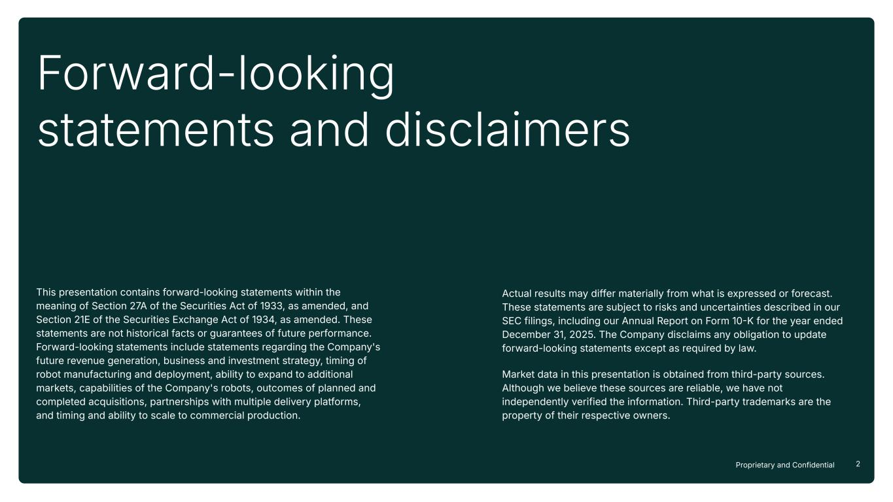
2Proprietary and Confidential Forward-looking statements and disclaimers This presentation contains forward-looking statements within the meaning of Section 27A of the Securities Act of 1933, as amended, and Section 21E of the Securities Exchange Act of 1934, as amended. These statements are not historical facts or guarantees of future performance. Forward-looking statements include statements regarding the Company's future revenue generation, business and investment strategy, timing of robot manufacturing and deployment, ability to expand to additional markets, capabilities of the Company's robots, outcomes of planned and completed acquisitions, partnerships with multiple delivery platforms, and timing and ability to scale to commercial production. Actual results may differ materially from what is expressed or forecast. These statements are subject to risks and uncertainties described in our SEC filings, including our Annual Report on Form 10K for the year ended December 31, 2025. The Company disclaims any obligation to update forward-looking statements except as required by law. Market data in this presentation is obtained from third-party sources. Although we believe these sources are reliable, we have not independently verified the information. Third-party trademarks are the property of their respective owners.

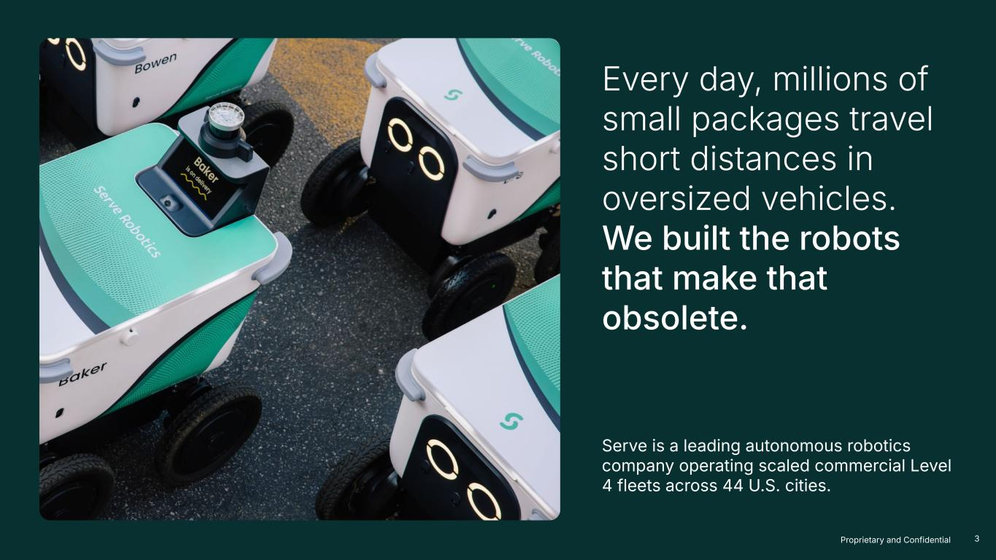
3Proprietary and Confidential Every day, millions of small packages travel short distances in oversized vehicles. We built the robots that make that obsolete. Serve is a leading autonomous robotics company operating scaled commercial Level 4 fleets across 44 U.S. cities.

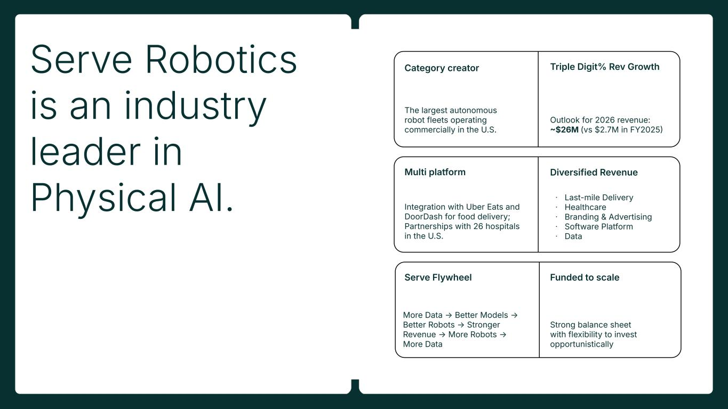
4Proprietary and Confidential Category creator The largest autonomous robot fleets operating commercially in the U.S. Multi platform Integration with Uber Eats and DoorDash for food delivery; Partnerships with 26 hospitals in the U.S. Triple Digit% Rev Growth Outlook for 2026 revenue: $26M (vs $2.7M in FY2025 Diversified Revenue ᐧ Last-mile Delivery ᐧ Healthcare ᐧ Branding & Advertising ᐧ Software Platform ᐧ Data Funded to scale Strong balance sheet with flexibility to invest opportunistically Serve Flywheel More Data → Better Models → Better Robots → Stronger Revenue → More Robots → More Data Serve Robotics is an industry leader in Physical AI.

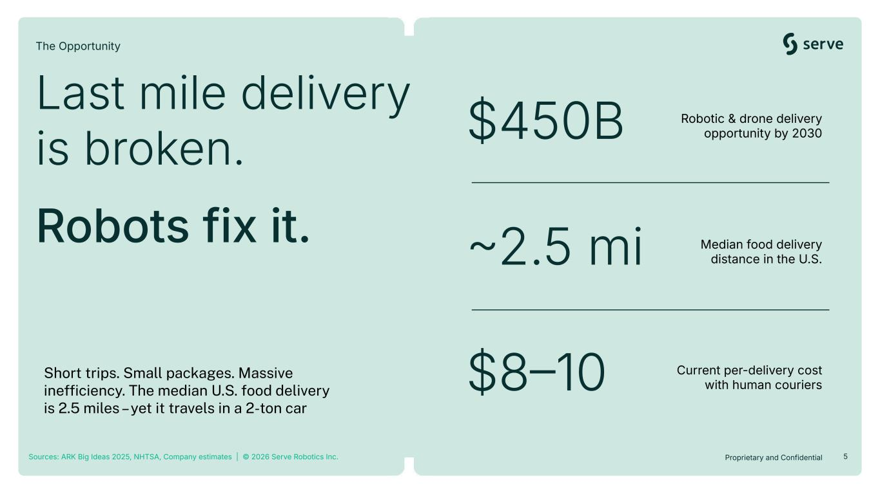
5Proprietary and Confidential $450B Robotic & drone delivery opportunity by 2030 2.5 mi Median food delivery distance in the U.S. $810 Current per-delivery cost with human couriers Sources: ARK Big Ideas 2025, NHTSA, Company estimates | © 2026 Serve Robotics Inc. Short trips. Small packages. Massive inefficiency. The median U.S. food delivery is 2.5 miles – yet it travels in a 2-ton car Last mile delivery is broken. Robots fix it. The Opportunity

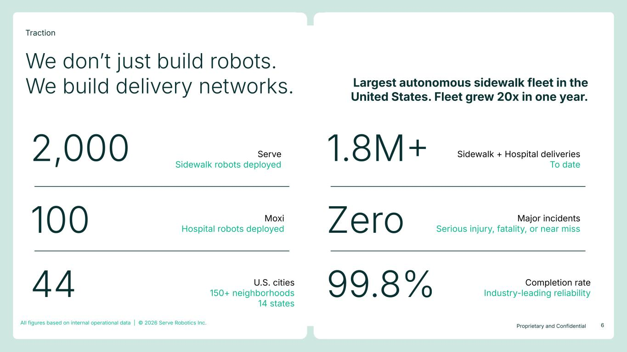
6Proprietary and Confidential 1.8M Sidewalk + Hospital deliveries To date Zero Major incidents Serious injury, fatality, or near miss 99.8% Completion rate Industry-leading reliability 2,000 100 Moxi Hospital robots deployed 44 U.S. cities 150+ neighborhoods 14 states We donʼt just build robots. We build delivery networks. Largest autonomous sidewalk fleet in the United States. Fleet grew 20x in one year. All figures based on internal operational data | © 2026 Serve Robotics Inc. Traction Serve Sidewalk robots deployed

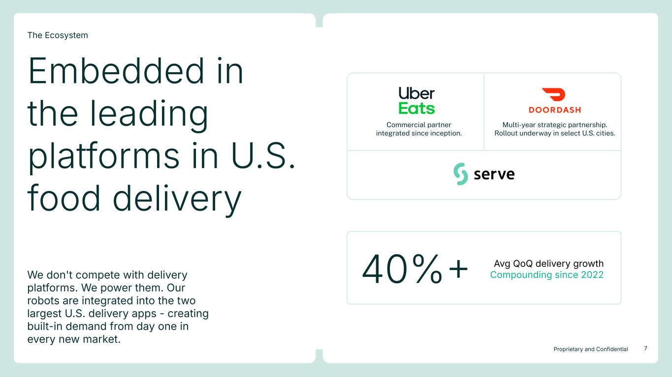
7Proprietary and Confidential Commercial partner integrated since inception. Multi-year strategic partnership. Rollout underway in select U.S. cities. We don't compete with delivery platforms. We power them. Our robots are integrated into the two largest U.S. delivery apps - creating built-in demand from day one in every new market. Embedded in the leading platforms in U.S. food delivery The Ecosystem 40% Avg QoQ delivery growth Compounding since 2022

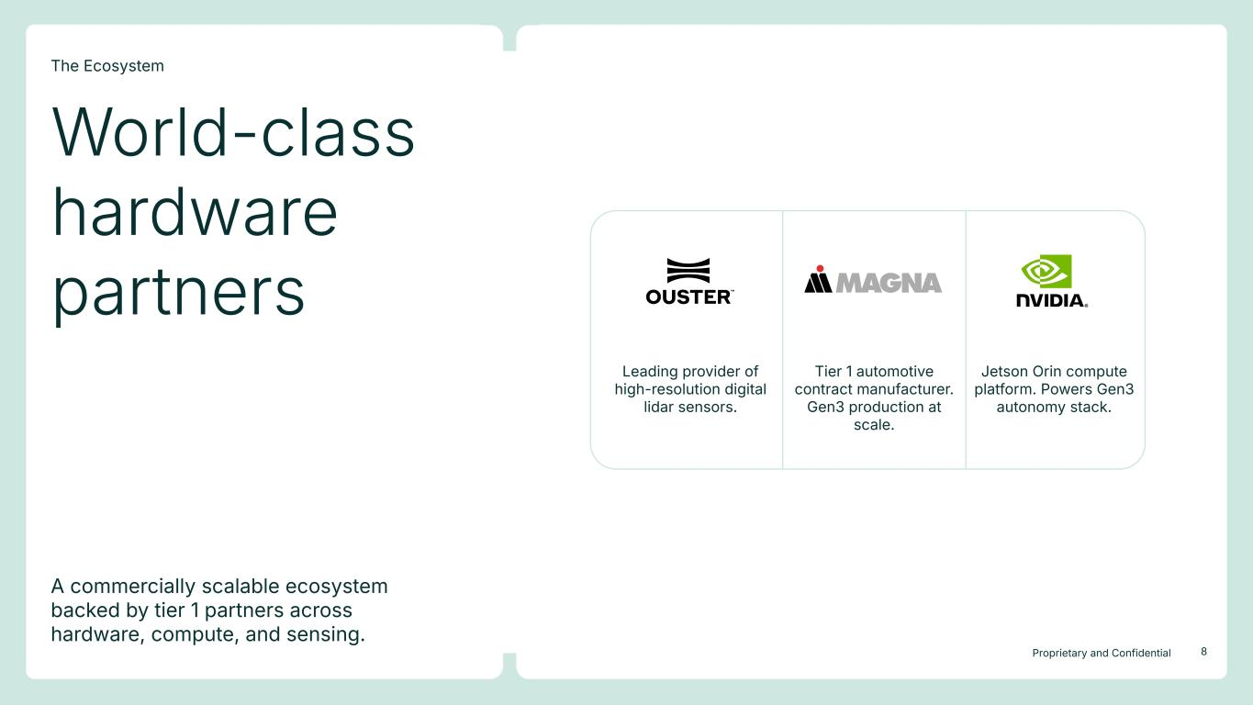
8Proprietary and Confidential A commercially scalable ecosystem backed by tier 1 partners across hardware, compute, and sensing. World-class hardware partners The Ecosystem Leading provider of high-resolution digital lidar sensors. Tier 1 automotive contract manufacturer. Gen3 production at scale. Jetson Orin compute platform. Powers Gen3 autonomy stack.

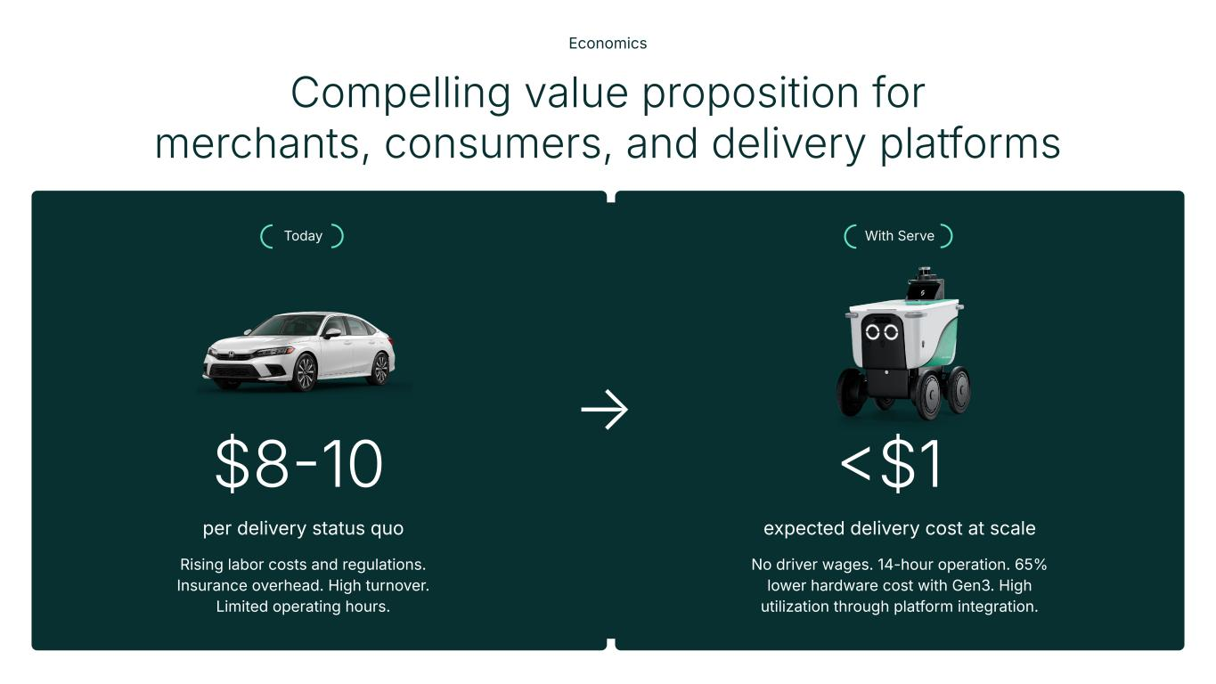
Compelling value proposition for merchants, consumers, and delivery platforms Economics With Serve Rising labor costs and regulations. Insurance overhead. High turnover. Limited operating hours. No driver wages. 14-hour operation. 65% lower hardware cost with Gen3. High utilization through platform integration. $810 per delivery status quo $1 expected delivery cost at scale Today →

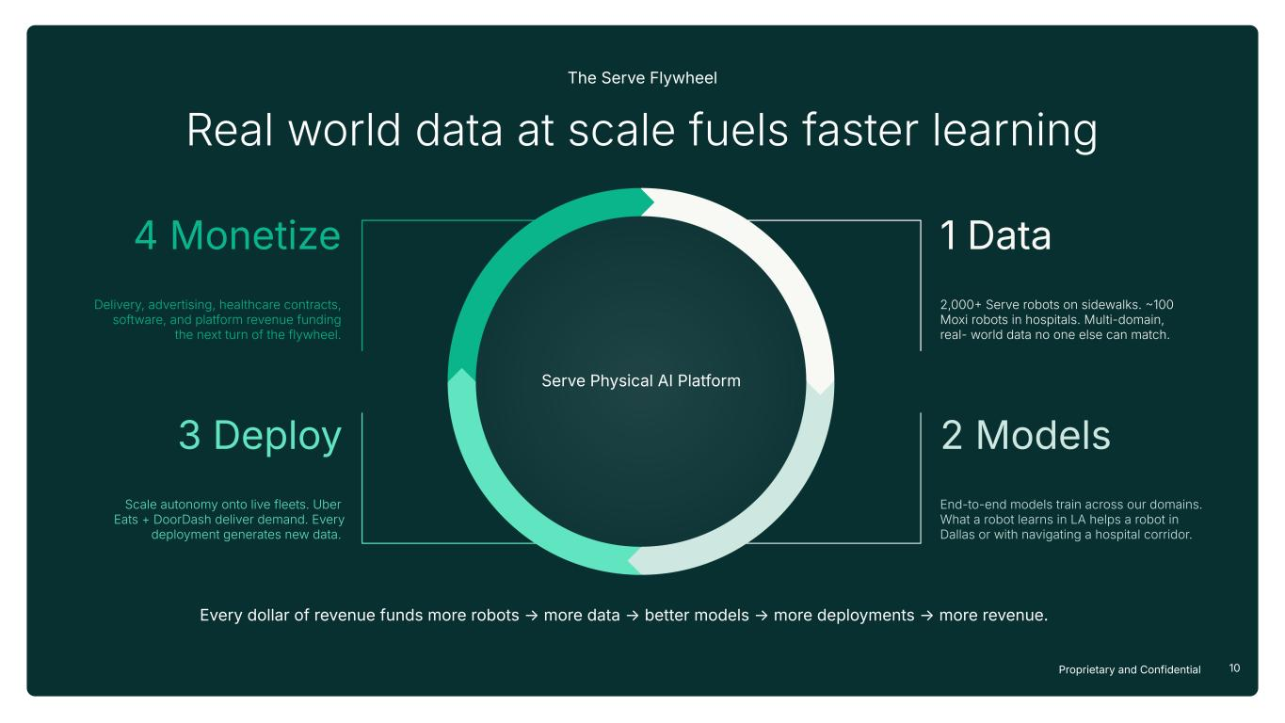
10Proprietary and Confidential Every dollar of revenue funds more robots → more data → better models → more deployments → more revenue. 2,000 Serve robots on sidewalks. 100 Moxi robots in hospitals. Multi-domain, real- world data no one else can match. 1 Data End-to-end models train across our domains. What a robot learns in LA helps a robot in Dallas or with navigating a hospital corridor. 2 Models Scale autonomy onto live fleets. Uber Eats + DoorDash deliver demand. Every deployment generates new data. 3 Deploy Delivery, advertising, healthcare contracts, software, and platform revenue funding the next turn of the flywheel. 4 Monetize Real world data at scale fuels faster learning The Serve Flywheel Serve Physical AI Platform

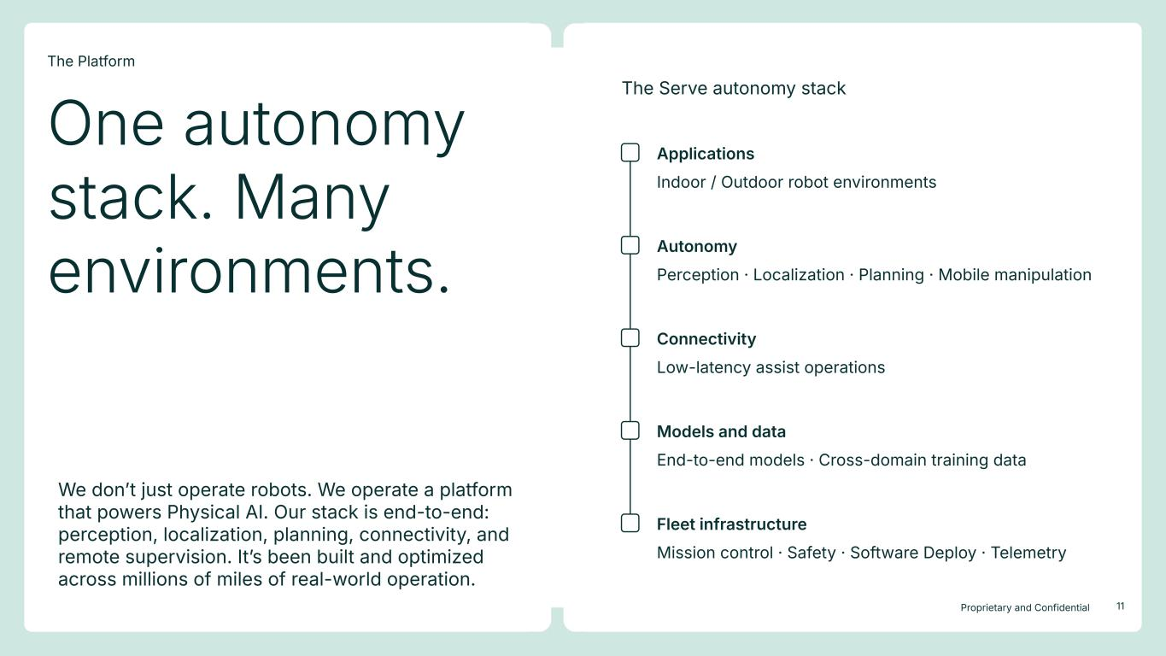
11Proprietary and Confidential We donʼt just operate robots. We operate a platform that powers Physical AI. Our stack is end-to-end: perception, localization, planning, connectivity, and remote supervision. Itʼs been built and optimized across millions of miles of real-world operation. Indoor / Outdoor robot environments Applications Perception · Localization · Planning · Mobile manipulation Autonomy Low-latency assist operations Connectivity End-to-end models · Cross-domain training data Models and data Mission control · Safety · Software Deploy · Telemetry Fleet infrastructure The Serve autonomy stack One autonomy stack. Many environments. The Platform

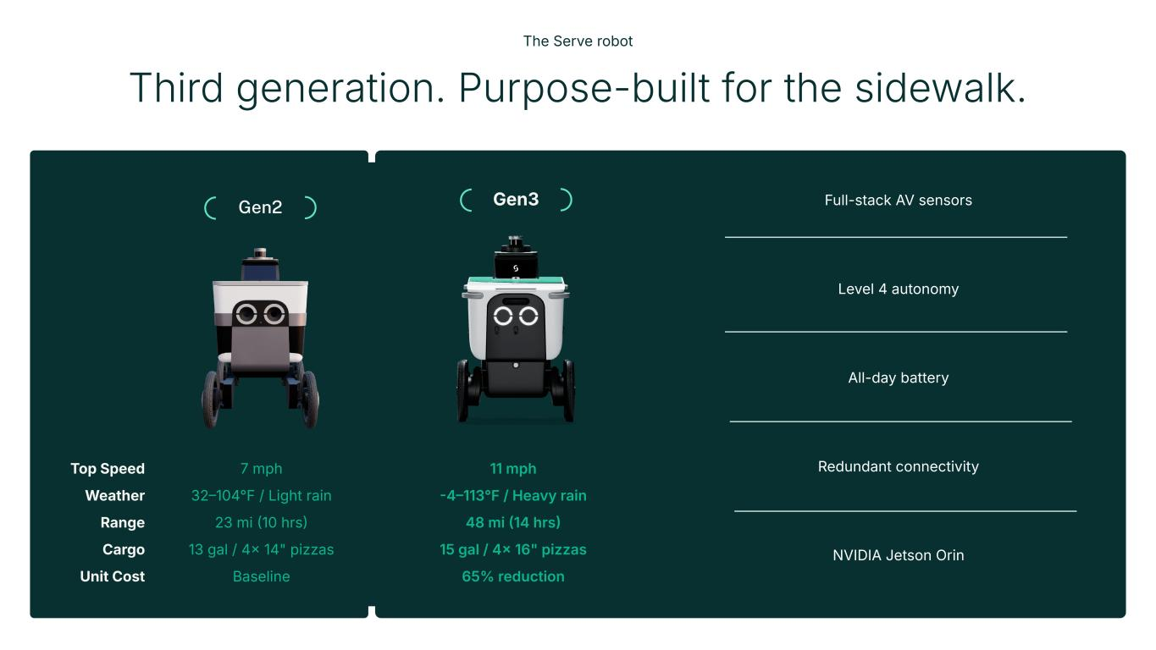
Gen2 Gen3 Top Speed 7 mph 11 mph Weather 32104°F / Light rain 4113°F / Heavy rain Range 23 mi 10 hrs 48 mi 14 hrs Cargo 13 gal / 4 14" pizzas 15 gal / 4 16" pizzas Unit Cost Baseline 65% reduction Full-stack AV sensors Level 4 autonomy All-day battery Redundant connectivity NVIDIA Jetson Orin Third generation. Purpose-built for the sidewalk. The Serve robot

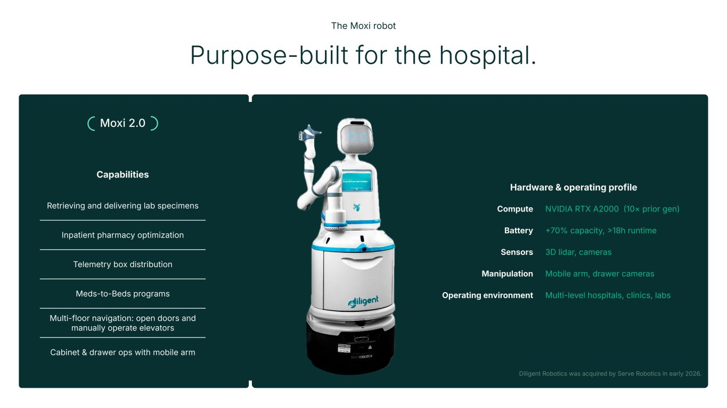
Purpose-built for the hospital. The Moxi robot Hardware & operating profile Compute NVIDIA RTX A2000 10× prior gen) Battery 70% capacity, 18h runtime Sensors 3D lidar, cameras Manipulation Mobile arm, drawer cameras Operating environment Multi-level hospitals, clinics, labs Diligent Robotics was acquired by Serve Robotics in early 2026. Moxi 2.0 Capabilities Retrieving and delivering lab specimens Inpatient pharmacy optimization Telemetry box distribution Meds-to-Beds programs Multi-floor navigation: open doors and manually operate elevators Cabinet & drawer ops with mobile arm

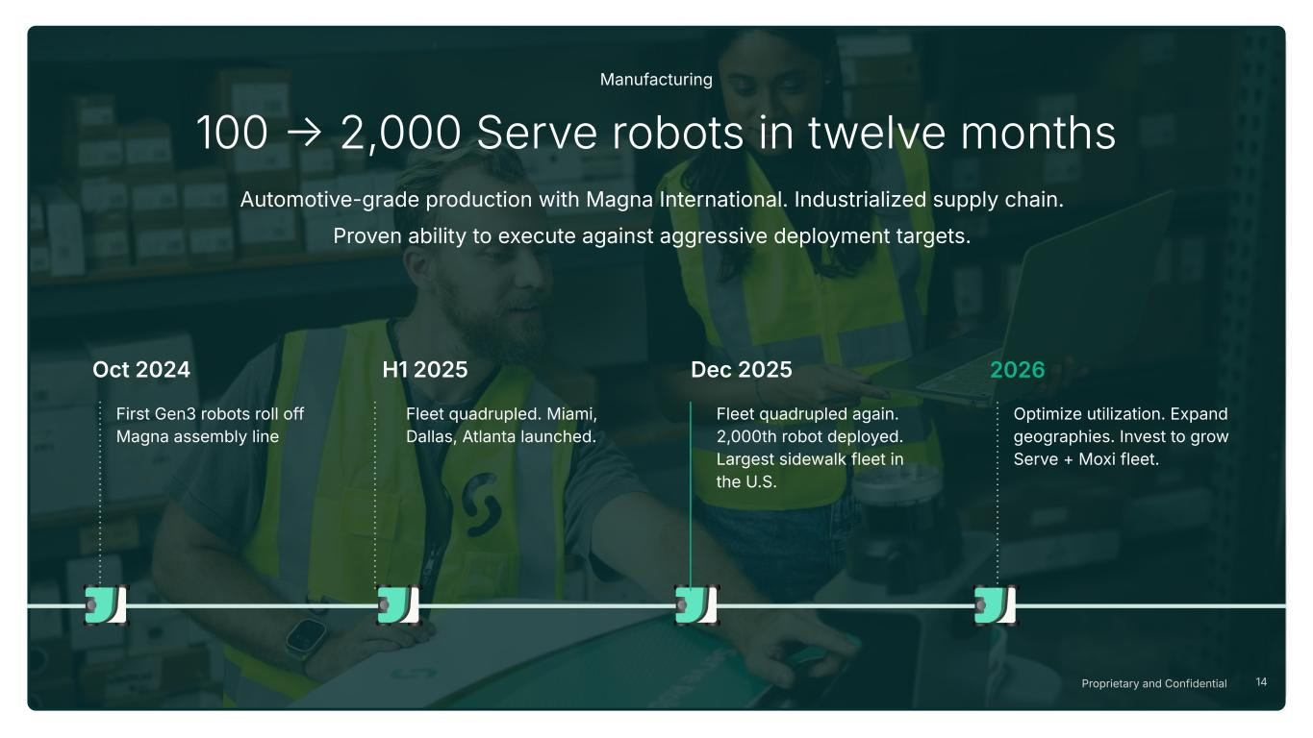
14Proprietary and Confidential First Gen3 robots roll off Magna assembly line Oct 2024 Fleet quadrupled. Miami, Dallas, Atlanta launched. H1 2025 Dec 2025 Fleet quadrupled again. 2,000th robot deployed. Largest sidewalk fleet in the U.S. 2026 Optimize utilization. Expand geographies. Invest to grow Serve + Moxi fleet. 100  2,000 Serve robots in twelve months Manufacturing Automotive-grade production with Magna International. Industrialized supply chain. Proven ability to execute against aggressive deployment targets.

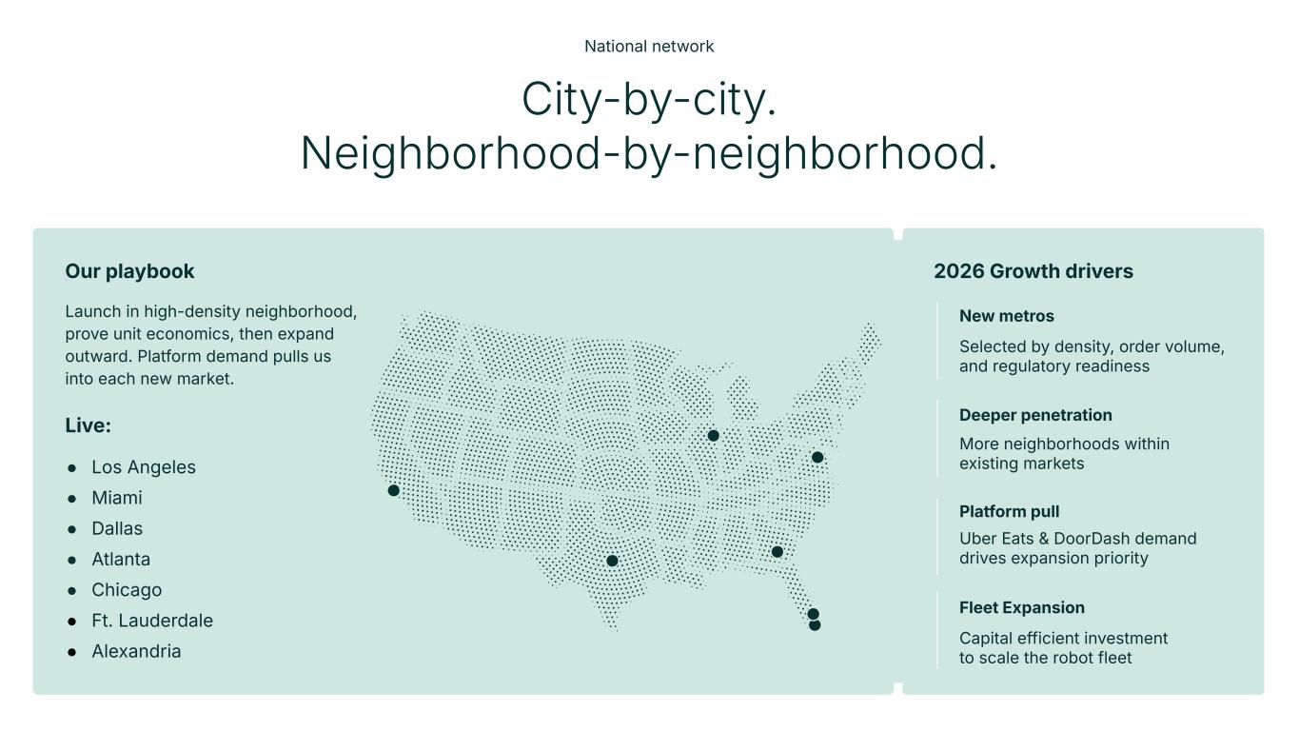
● Los Angeles ● Miami ● Dallas ● Atlanta ● Chicago ● Ft. Lauderdale ● Alexandria Live: 2026 Growth drivers New metros Selected by density, order volume, and regulatory readiness Deeper penetration More neighborhoods within existing markets Platform pull Uber Eats & DoorDash demand drives expansion priority Fleet Expansion Capital efficient investment to scale the robot fleet City-by-city. Neighborhood-by-neighborhood. National network Our playbook Launch in high-density neighborhood, prove unit economics, then expand outward. Platform demand pulls us into each new market.

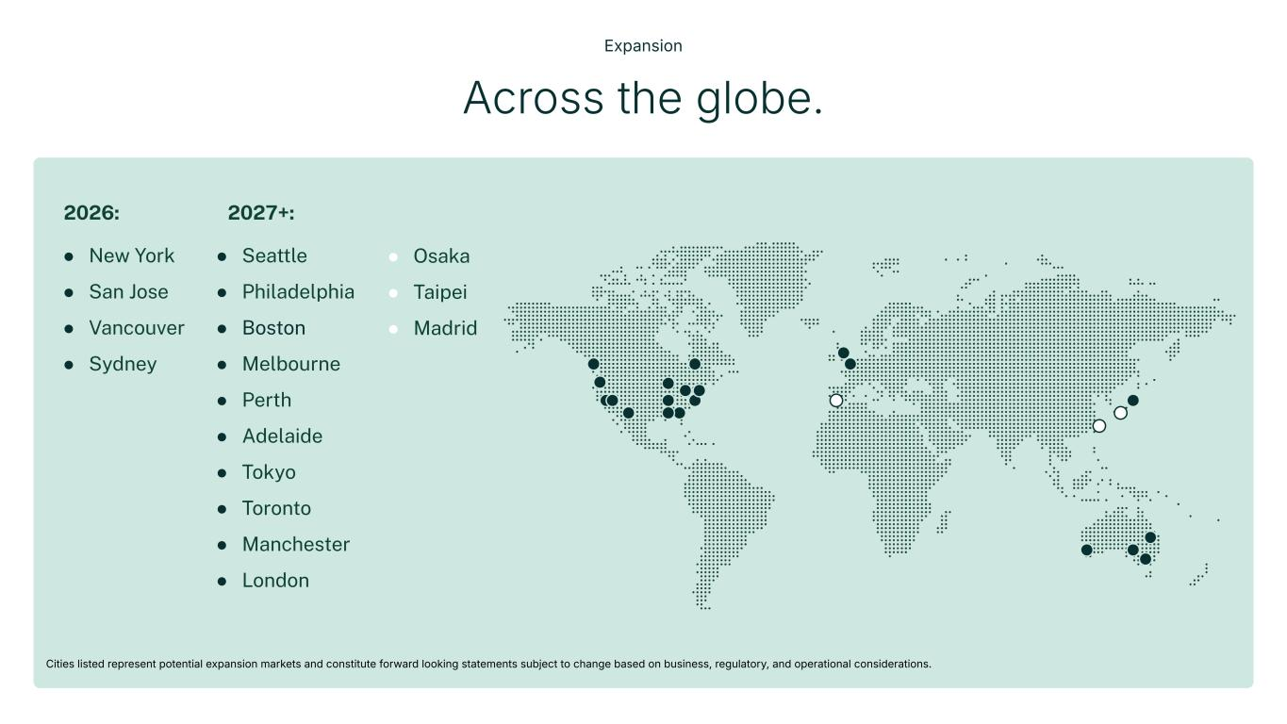
CITIES LIST City by city. Neighborhood by neighborhood. ● New York ● San Jose ● Vancouver ● Sydney 2026: ● Seattle ● Philadelphia ● Boston ● Melbourne ● Perth ● Adelaide ● Tokyo ● Toronto ● Manchester ● London 2027+: ● Osaka ● Taipei ● Madrid Cities listed represent potential expansion markets and constitute forward looking statements subject to change based on business, regulatory, and operational considerations. Across the globe. Expansion

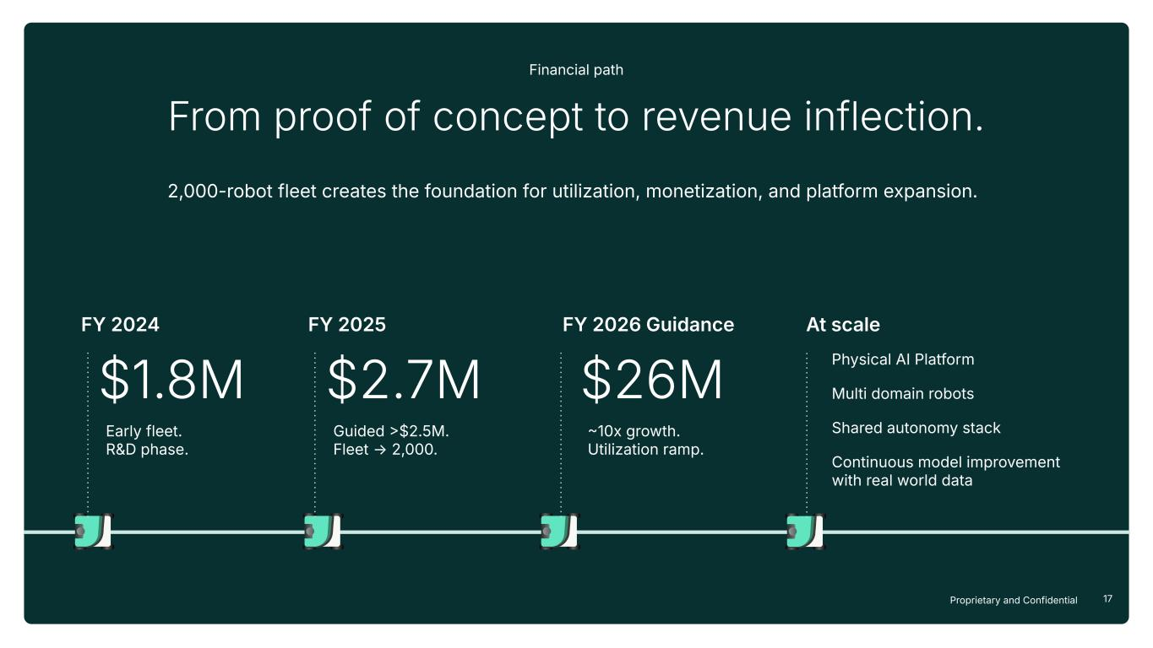
17Proprietary and Confidential From proof of concept to revenue inflection. Financial path 2,000-robot fleet creates the foundation for utilization, monetization, and platform expansion. FY 2024 FY 2025 $1.8M Early fleet. R&D phase. $2.7M Guided $2.5M. Fleet → 2,000. FY 2026 Guidance $26M 10x growth. Utilization ramp. At scale Physical AI Platform Multi domain robots Shared autonomy stack Continuous model improvement with real world data

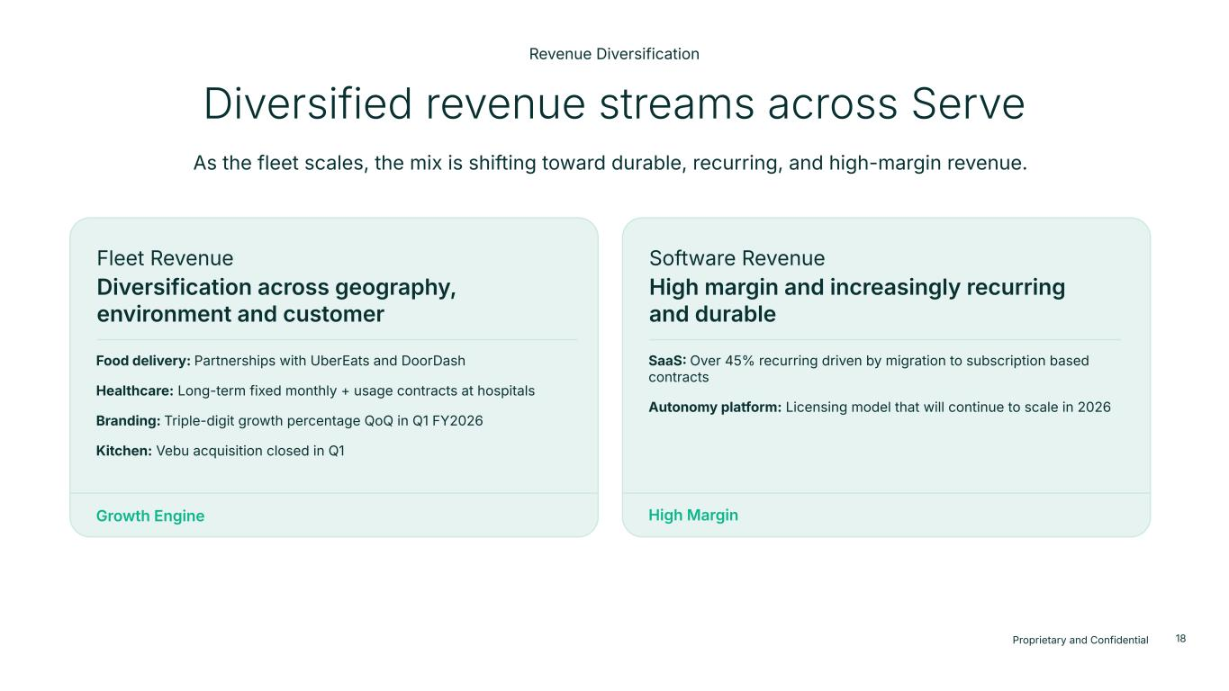
18Proprietary and Confidential 18 Diversification across geography, environment and customer Fleet Revenue Growth Engine Diversified revenue streams across Serve Revenue Diversification Food delivery: Partnerships with UberEats and DoorDash Healthcare: Long-term fixed monthly + usage contracts at hospitals Branding: Triple-digit growth percentage QoQ in Q1 FY2026 Kitchen: Vebu acquisition closed in Q1 High margin and increasingly recurring and durable Software Revenue High Margin SaaS Over 45% recurring driven by migration to subscription based contracts Autonomy platform: Licensing model that will continue to scale in 2026 As the fleet scales, the mix is shifting toward durable, recurring, and high-margin revenue.

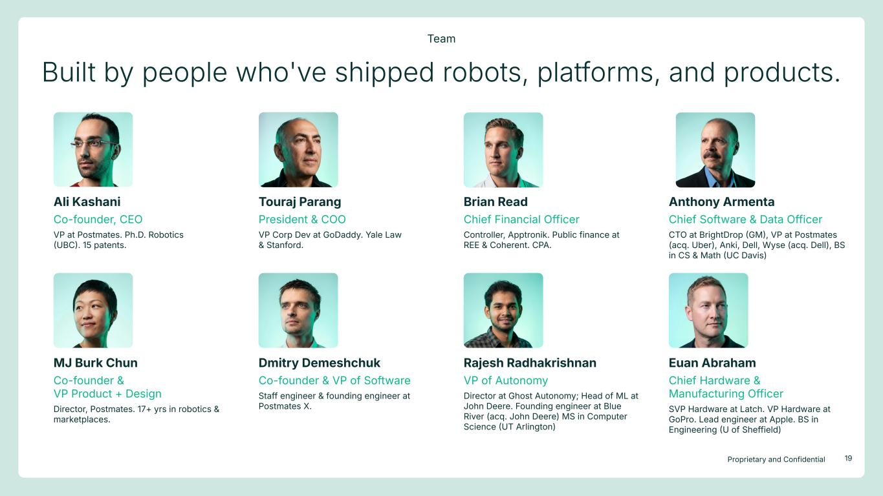
19Proprietary and Confidential Built by people who've shipped robots, platforms, and products. Team Ali Kashani Co-founder, CEO VP at Postmates. Ph.D. Robotics UBC. 15 patents. Touraj Parang President & COO VP Corp Dev at GoDaddy. Yale Law & Stanford. MJ Burk Chun Co-founder & VP Product + Design Director, Postmates. 17+ yrs in robotics & marketplaces. Brian Read Chief Financial Officer Controller, Apptronik. Public finance at REE & Coherent. CPA. Dmitry Demeshchuk Co-founder & VP of Software Staff engineer & founding engineer at Postmates X. Anthony Armenta Chief Software & Data Officer CTO at BrightDrop GM, VP at Postmates (acq. Uber), Anki, Dell, Wyse (acq. Dell), BS in CS & Math UC Davis) Rajesh Radhakrishnan VP of Autonomy Director at Ghost Autonomy; Head of ML at John Deere. Founding engineer at Blue River (acq. John Deere) MS in Computer Science UT Arlington) Euan Abraham Chief Hardware & Manufacturing Officer SVP Hardware at Latch. VP Hardware at GoPro. Lead engineer at Apple. BS in Engineering U of Sheffield)

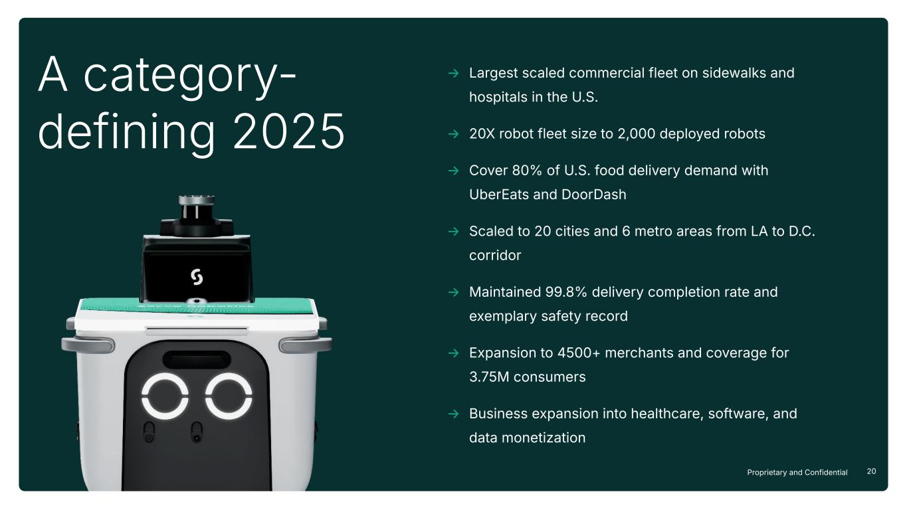
20Proprietary and Confidential A category- defining 2025 → Largest scaled commercial fleet on sidewalks and hospitals in the U.S. → 20X robot fleet size to 2,000 deployed robots → Cover 80% of U.S. food delivery demand with UberEats and DoorDash → Scaled to 20 cities and 6 metro areas from LA to D.C. corridor → Maintained 99.8% delivery completion rate and exemplary safety record → Expansion to 4500+ merchants and coverage for 3.75M consumers → Business expansion into healthcare, software, and data monetization

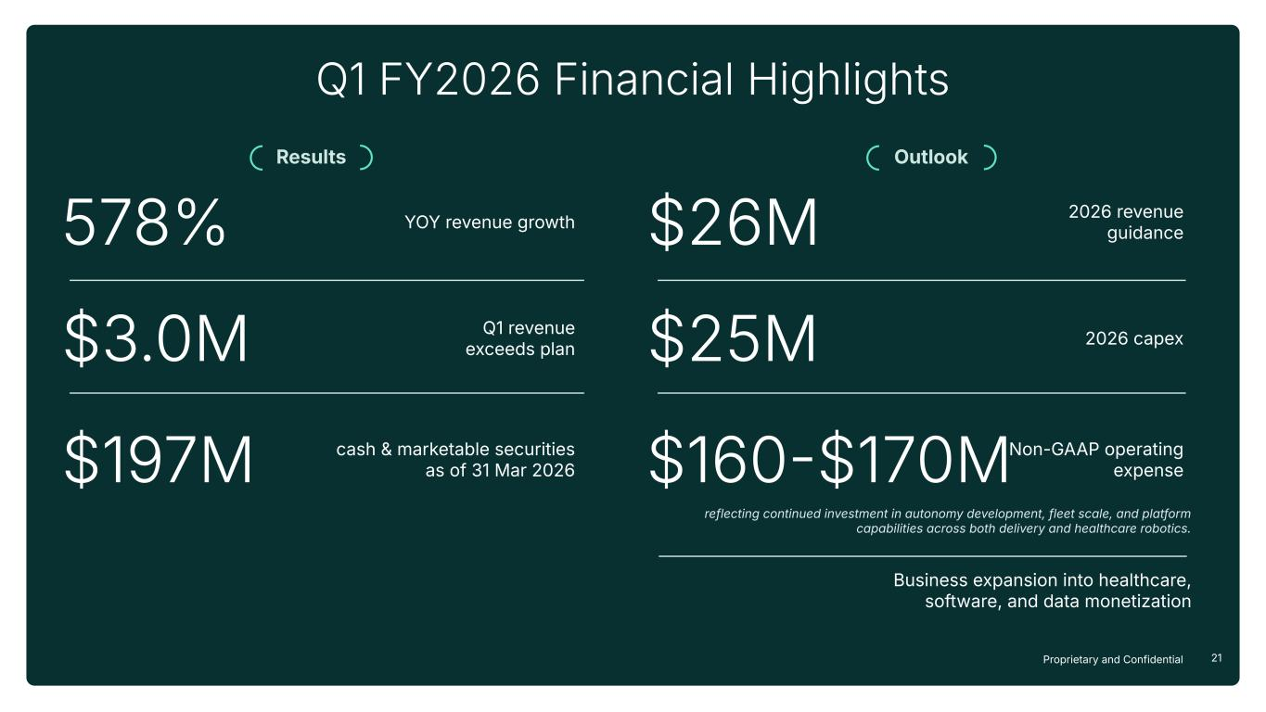
21Proprietary and Confidential Q1 FY2026 Financial Highlights $3.0M Q1 revenue exceeds plan 578% $197M cash & marketable securities as of 31 Mar 2026 Results Outlook YOY revenue growth $26M 2026 revenue guidance $25M 2026 capex $160$170MNon-GAAP operating expense reflecting continued investment in autonomy development, fleet scale, and platform capabilities across both delivery and healthcare robotics. Business expansion into healthcare, software, and data monetization

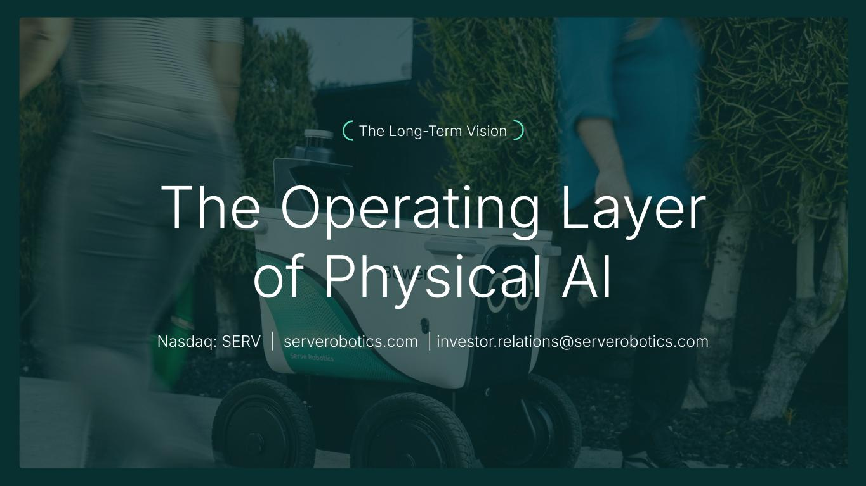
Slide 16 Header: The Long-Term Vision Unbundling the car for dense cities Specialized autonomous robots for everyday urban tasks. ● Safer streets ● Lower emissions ● More efficient local commerce Design direction: Strong closing image. Minimal text. One idea only. The Operating Layer of Physical AI Nasdaq: SERV | serverobotics.com | investor.relations@serverobotics.com The Long-Term Vision

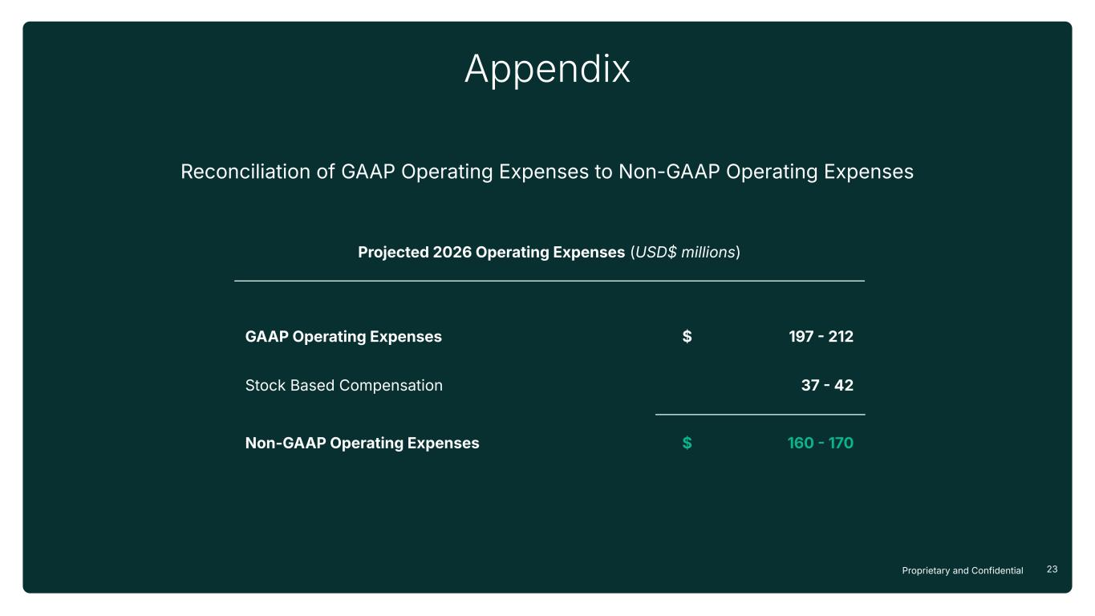
23Proprietary and Confidential Appendix Projected 2026 Operating Expenses (USD$ millions) GAAP Operating Expenses $ 197  212 Stock Based Compensation 37  42 Non-GAAP Operating Expenses $ 160  170 Reconciliation of GAAP Operating Expenses to Non-GAAP Operating Expenses

